# 29.07- Genereal Research and Presentation

github base repo: https://gitlab.bewelltech.com.tr/Intern4/uav-building-detection

New dataset: <https://www.sciencedirect.com/science/article/pii/S1569843222001595>

# **A context-scale-aware detector and a new benchmark for remote sensing small weak object detection in unmanned aerial vehicle images**

To achieve real-scenario small weak object detection in UAV images, we present a 10-category dataset, UAVOD-10, consisting of 844 images and 18,234 instances. These instances are labeled with horizontal bounding boxes (HBBs). The images’ widths range from 1000 to 4800 pixels, and their resolutions are approximately 0.15 m. As shown in Table 1, the phenomenon of class imbalance exists in the dataset, wherein building and prefabricated house objects have many instances, and quarry, pool, and landslide objects are fewer. Scale differences in objects of the same or different categories are apparent. The width of the smallest building instance is 9 pixels, the biggest one’s width is 312 pixels, and the mean width is 74.85 pixels. Other classes, such as quarry, pool, and landslide, have larger average widths and standard deviations. These problems of class imbalance and scale difference are consistent with real-world applications.

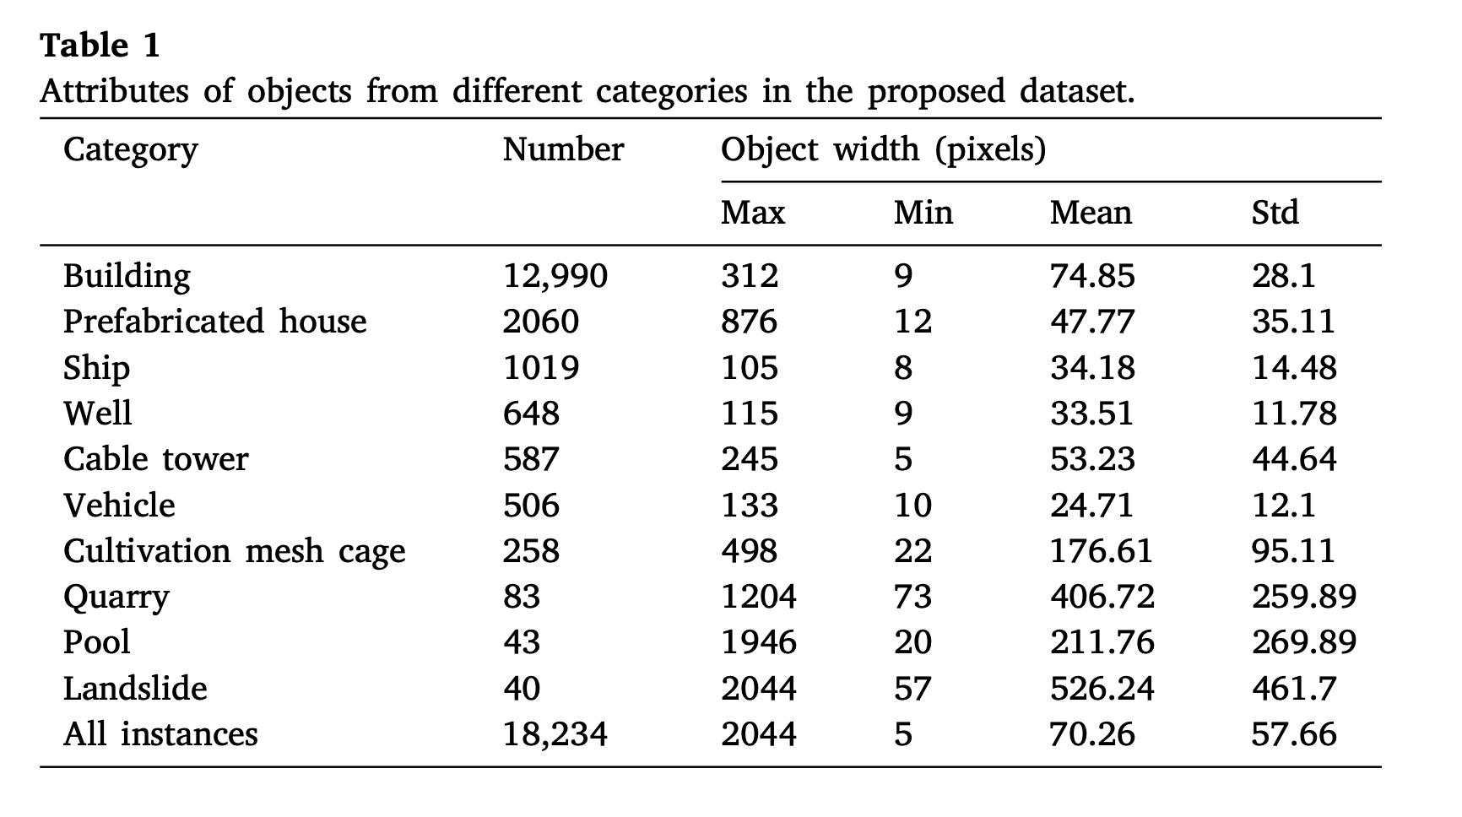

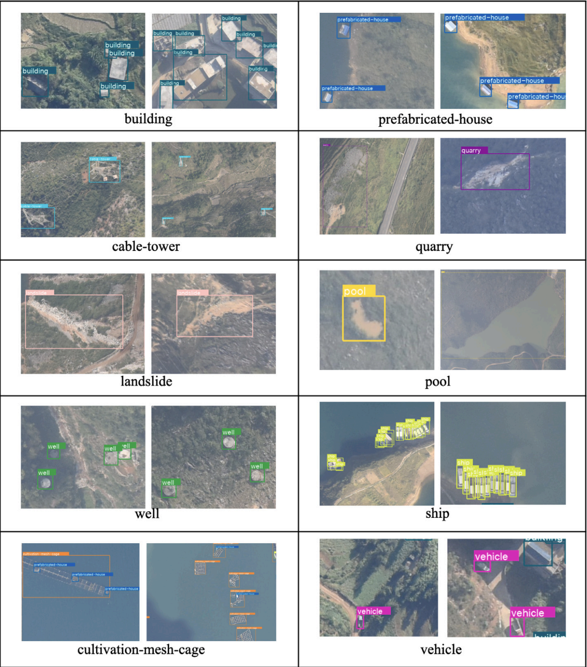

## New Tasks

## Tests on the new dataset (UAVOD-10). UAV images for detecting buildings. For UAV images

## Gathering the location information from images.

## Extend the tests on rescuenet dataset

## Multiclass classification for buildings (minor-medium damaged buildings)

T1- Write a clean and single script that digging data from image masks and converting to yolo format. For “rescuenet” and “uavod-10” datasets

T2 – Upload UAVOD-10 dataset to "Gdrive" for ease of access

T3- Comet-ML infrastructure base notebook for runs.

for obj in root.iter('object'):

cls = obj.find('name').text

if cls == "building":

cls_id = 0

elif cls == "prefabricated-house":

cls_id = 1

elif cls == "vehicle":

cls_id = 2

else:

continue

difficult = obj.find('difficult').text

if int(difficult) == 1:

continue

YOLOV8N VS YOLOV8S ON 30 EPOCHS AND 16 BATCH SIZE

nano:

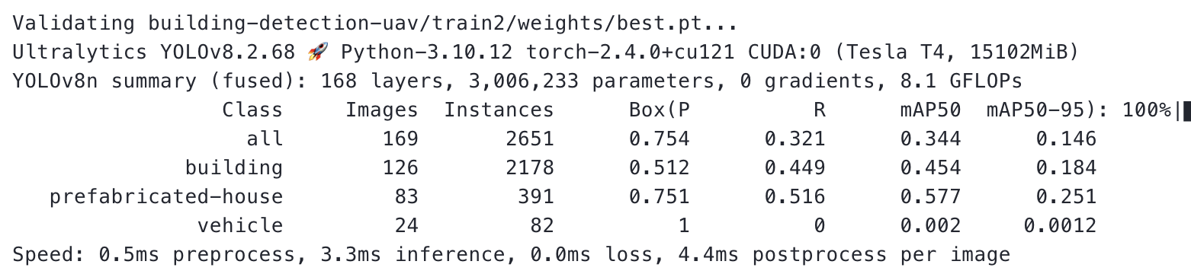

small:

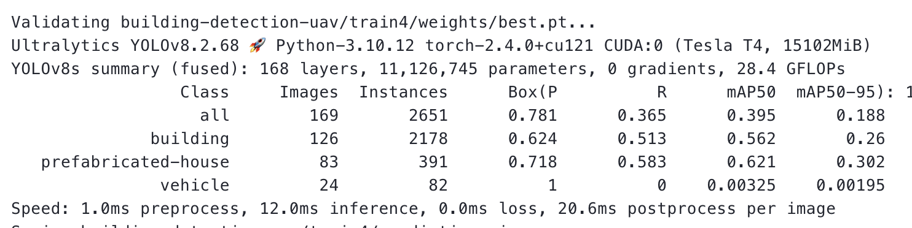

nano:

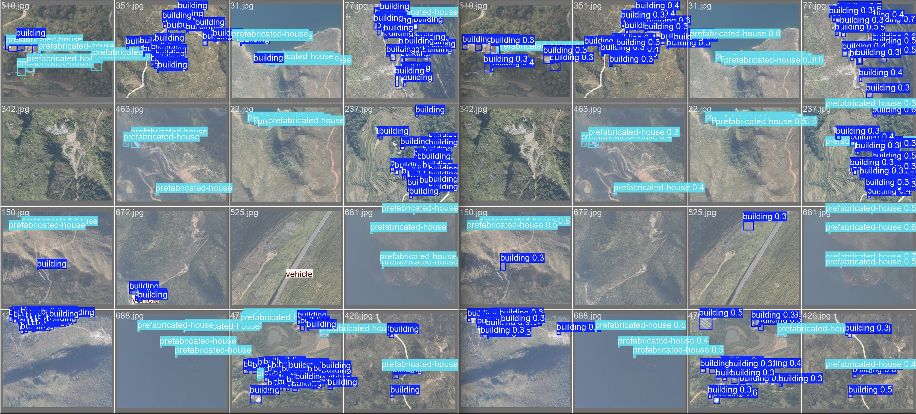

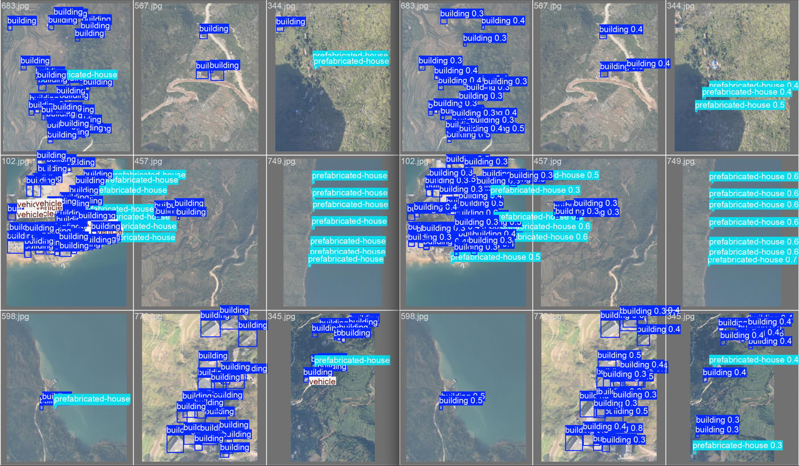small:

# 30.07- GOING ON NEW TASKS

Vehicle class can be removed from labels. There are only a bunch of vehicles so it leads our case to an imbalance data problem.

Tasks from yesterday

T1- Write a clean and single script that digging data from image masks and converting to yolo format. For “rescuenet” and “~~uavod-10~~” datasets

~~T2 – Upload UAVOD-10 dataset to "Gdrive" for ease of access~~

~~T3- Comet-ML infrastructure base notebook for runs.~~

T4 - Precise location detection continuos at (Rescuenet project)

~~T5 - Vehicle class removal from labels and new tests~~

size problem on runs: save only best and last epoch config.

Check results at url: [cometML portal](https://www.comet.com/dolphinium/building-detection-uav/view/new/panels)

Model comparison YOLOV8[N-S-X]

yolov8x 30 epoch 16 batch size

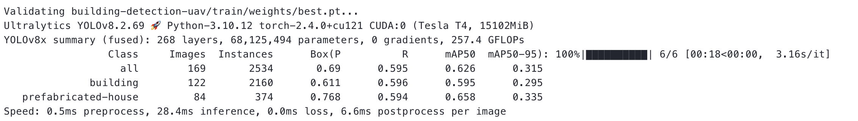

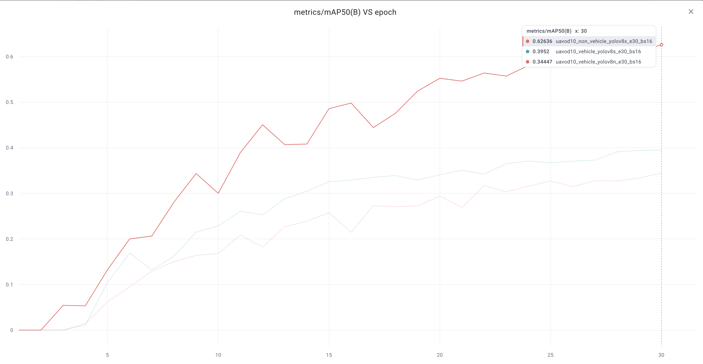

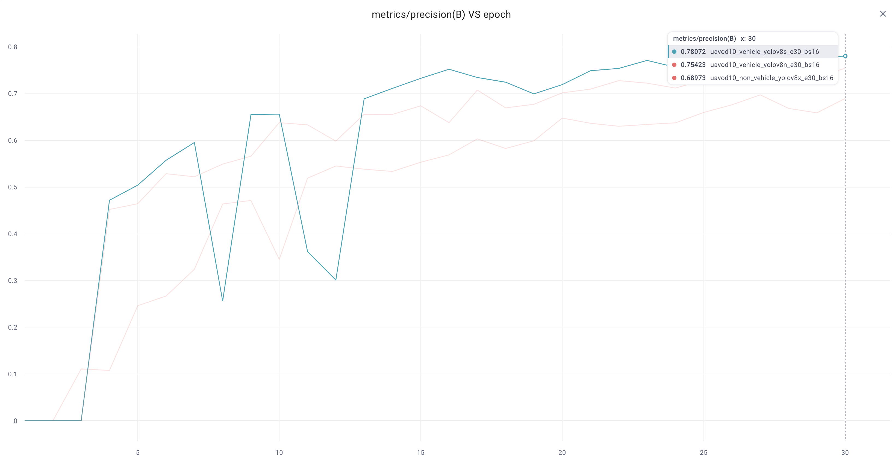

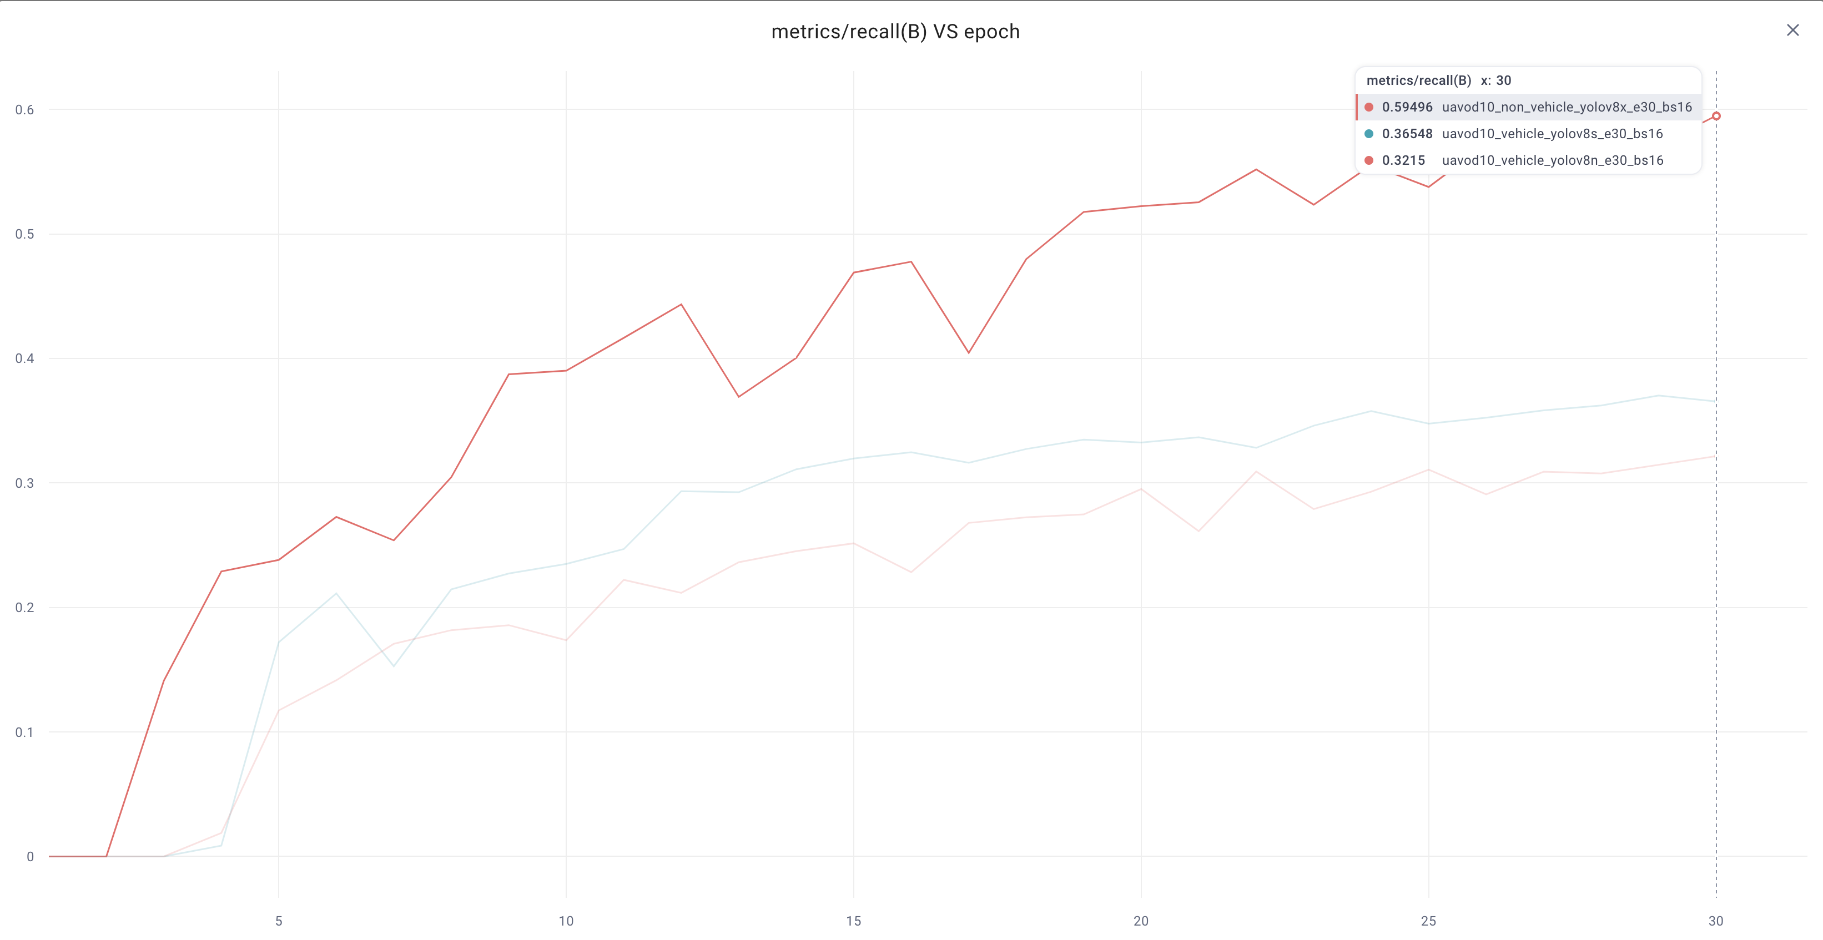

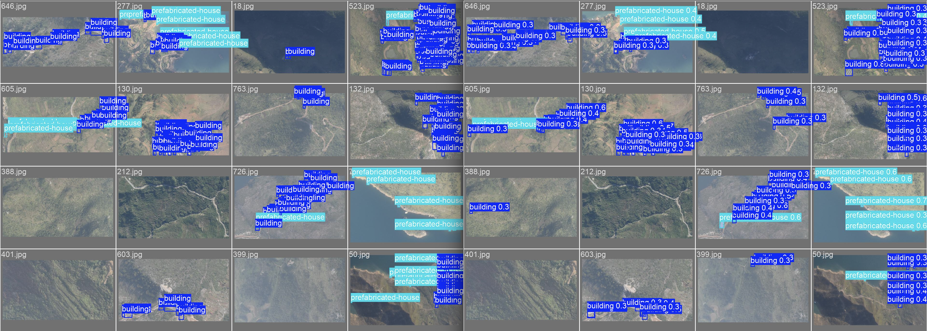

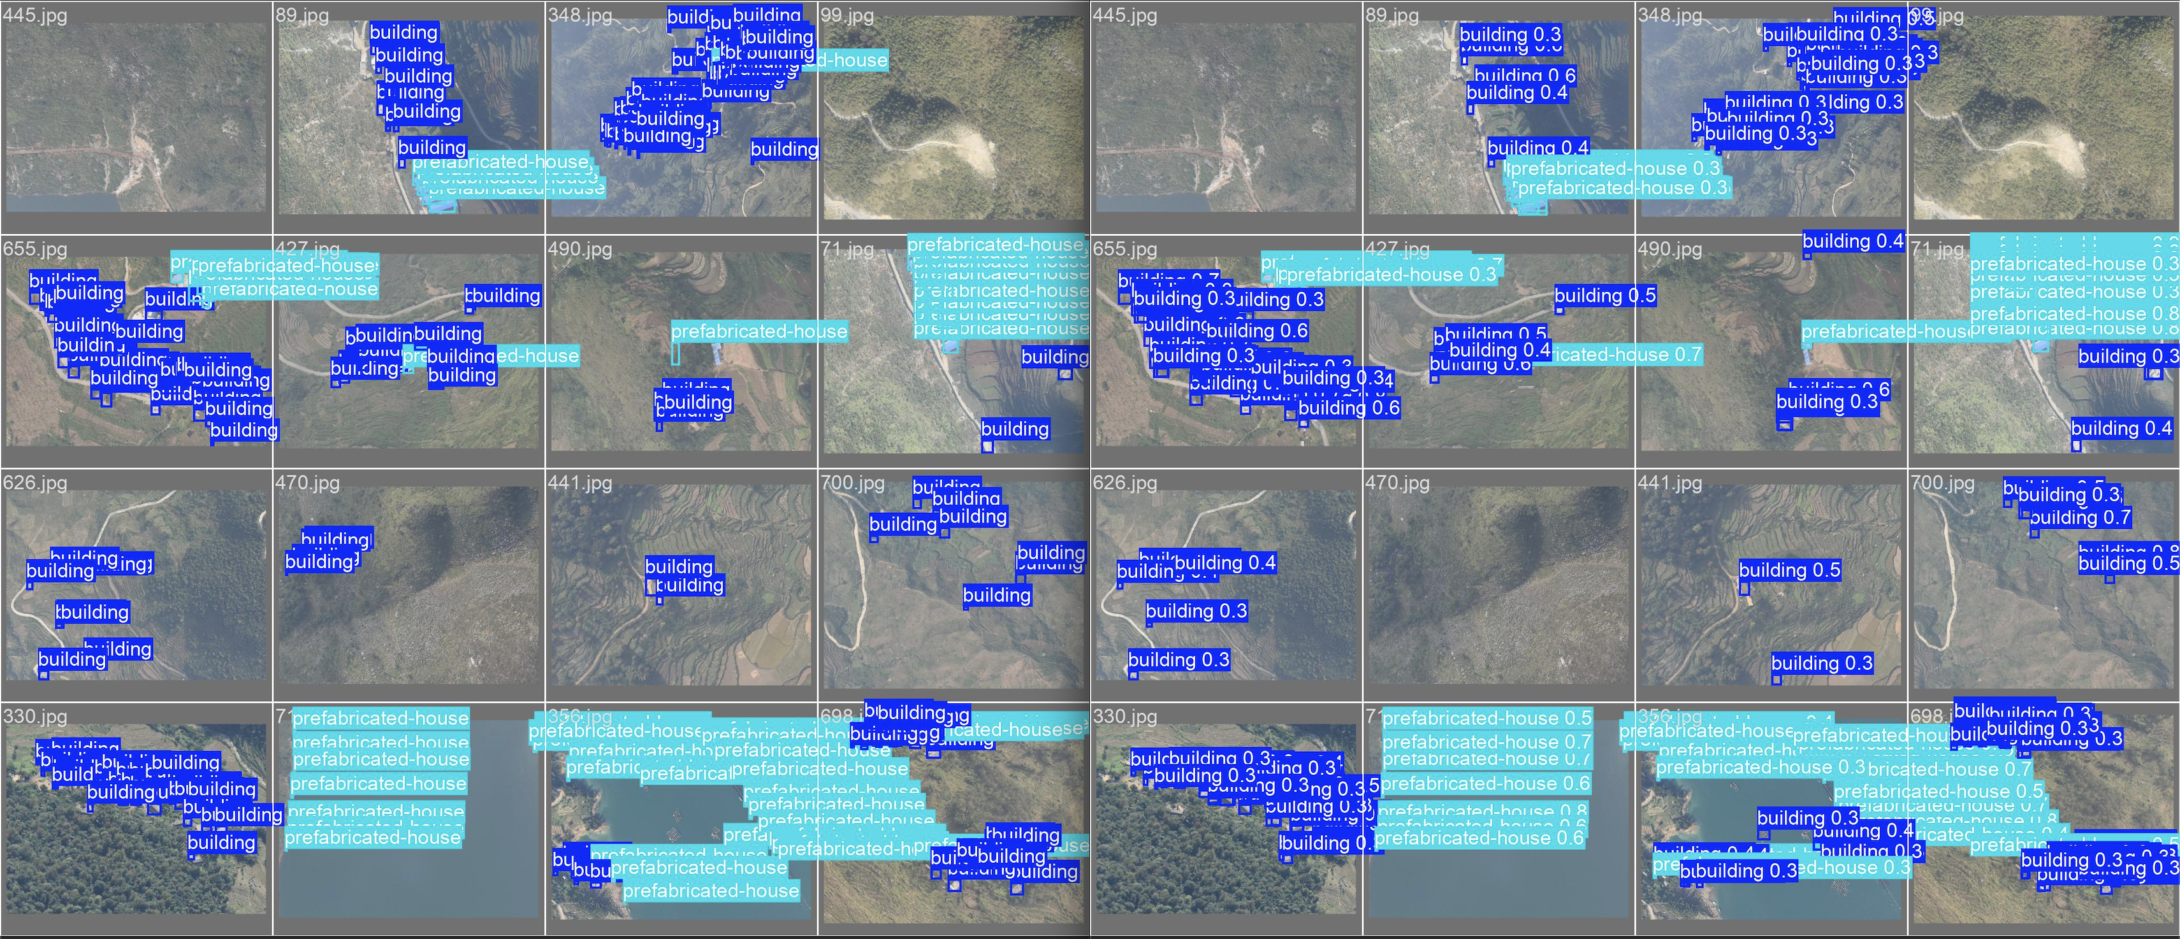

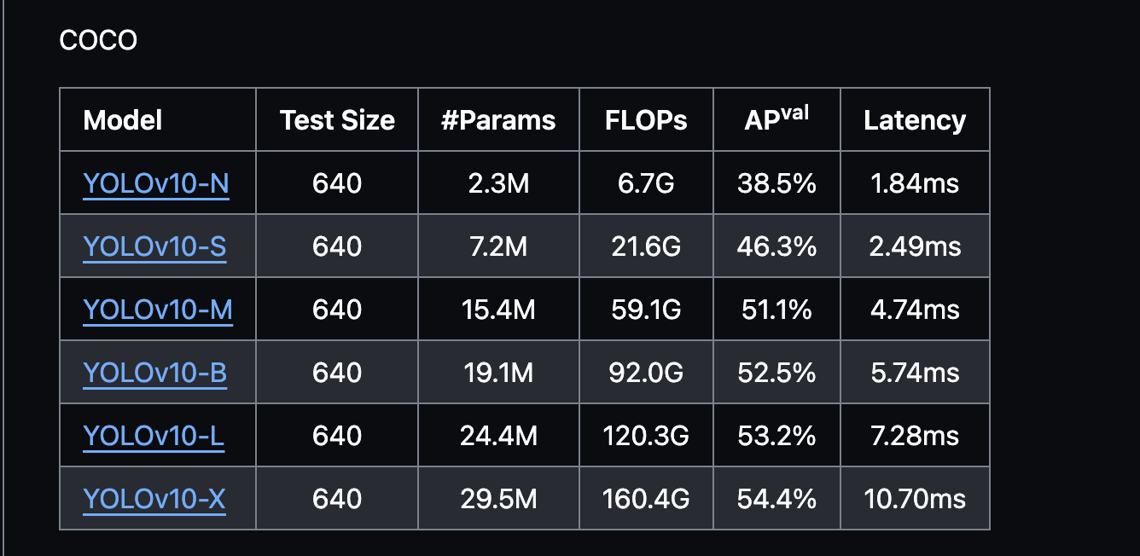

YOLOV10 TESTS- N-S-M

N:

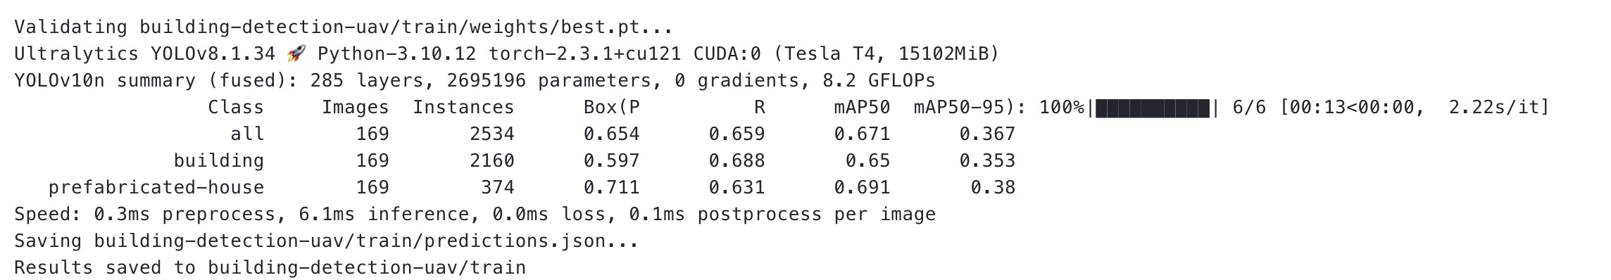

S:

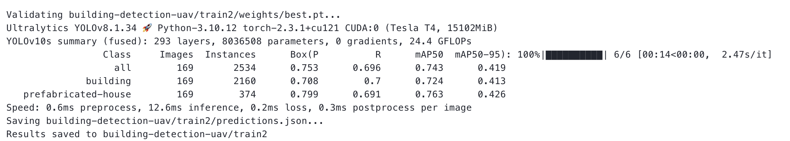

M:

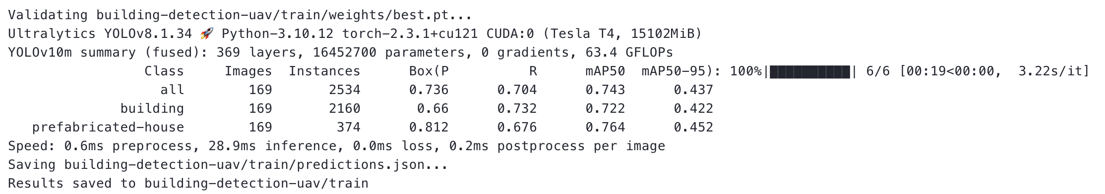

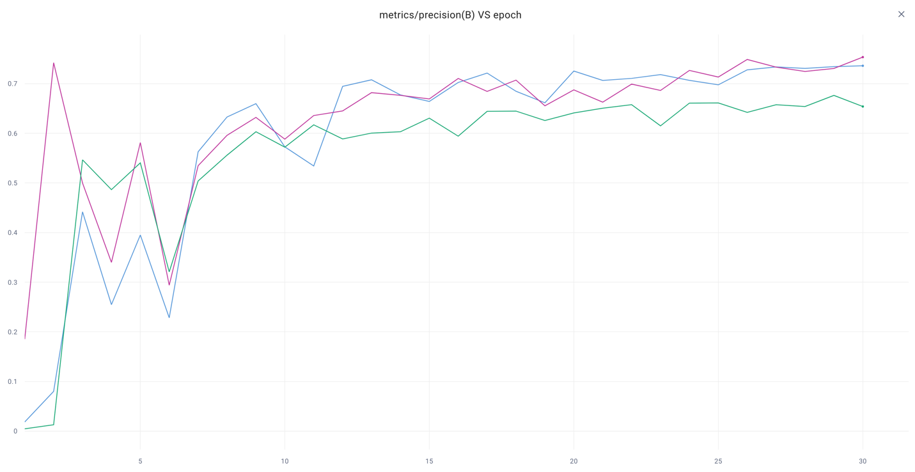

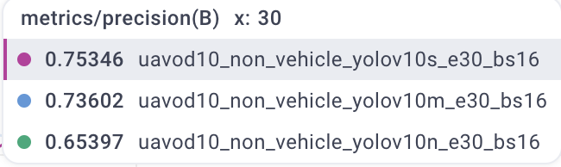

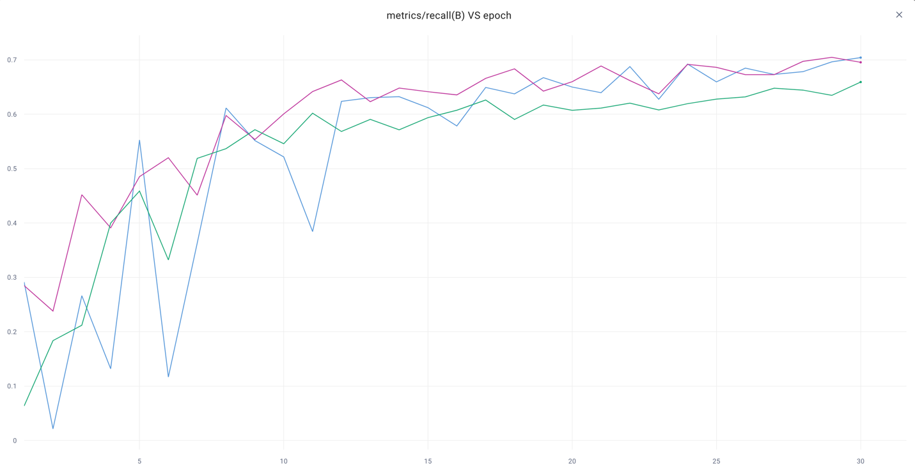

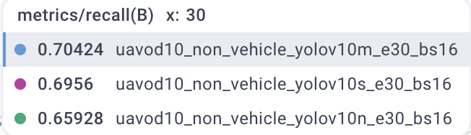

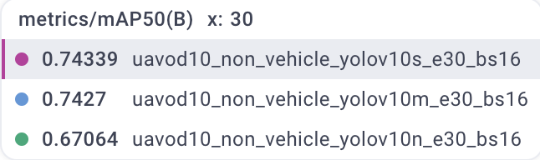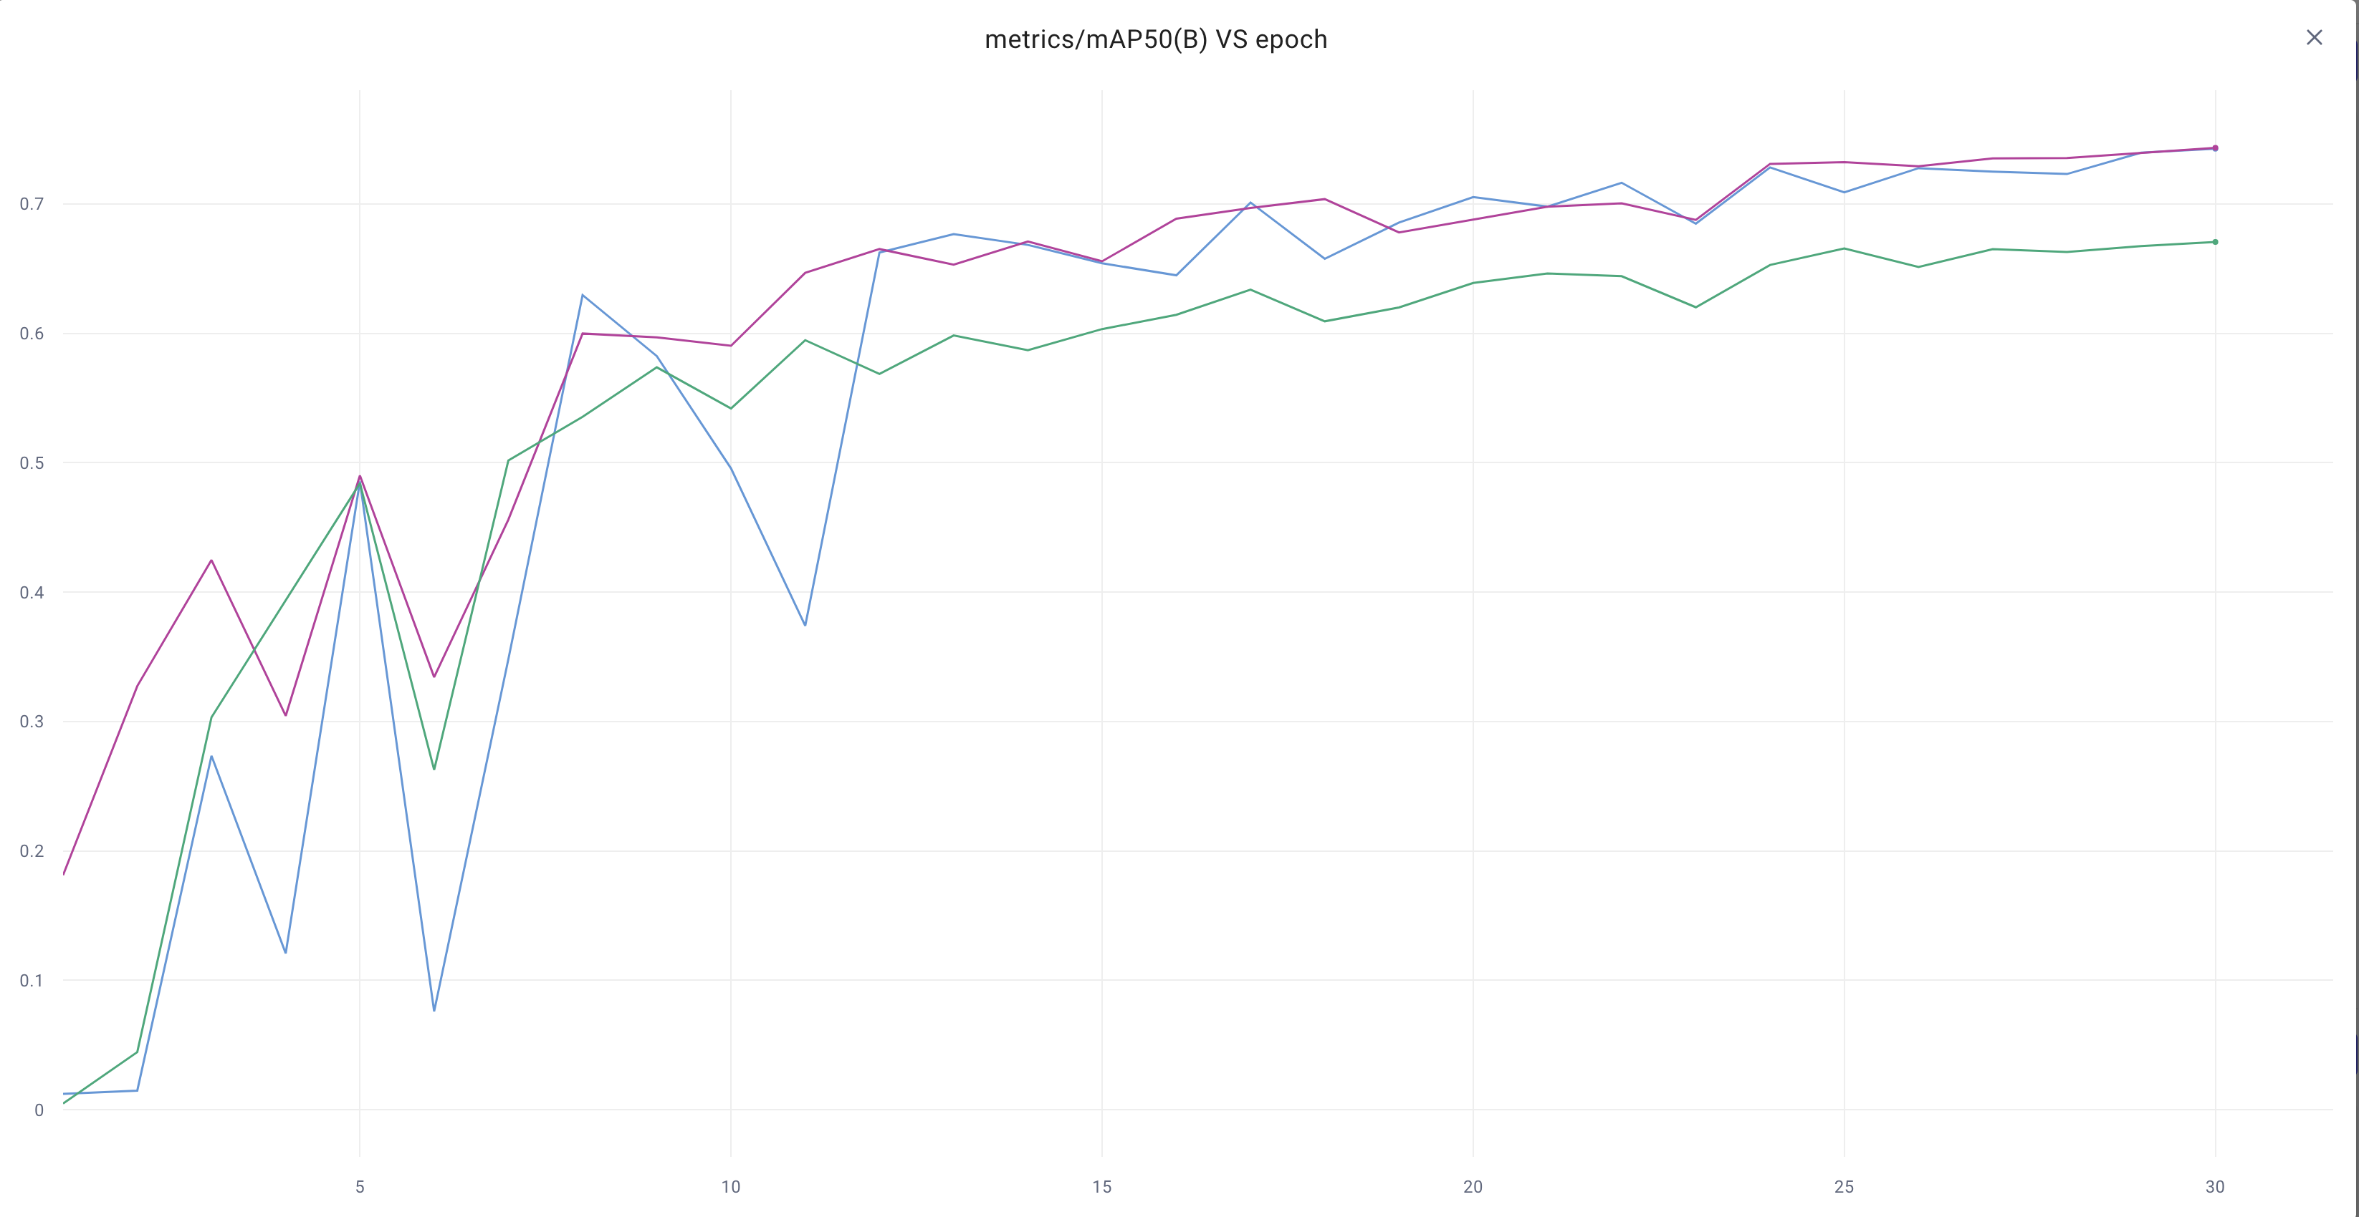

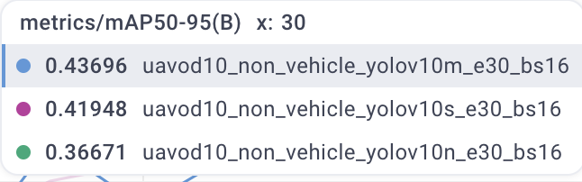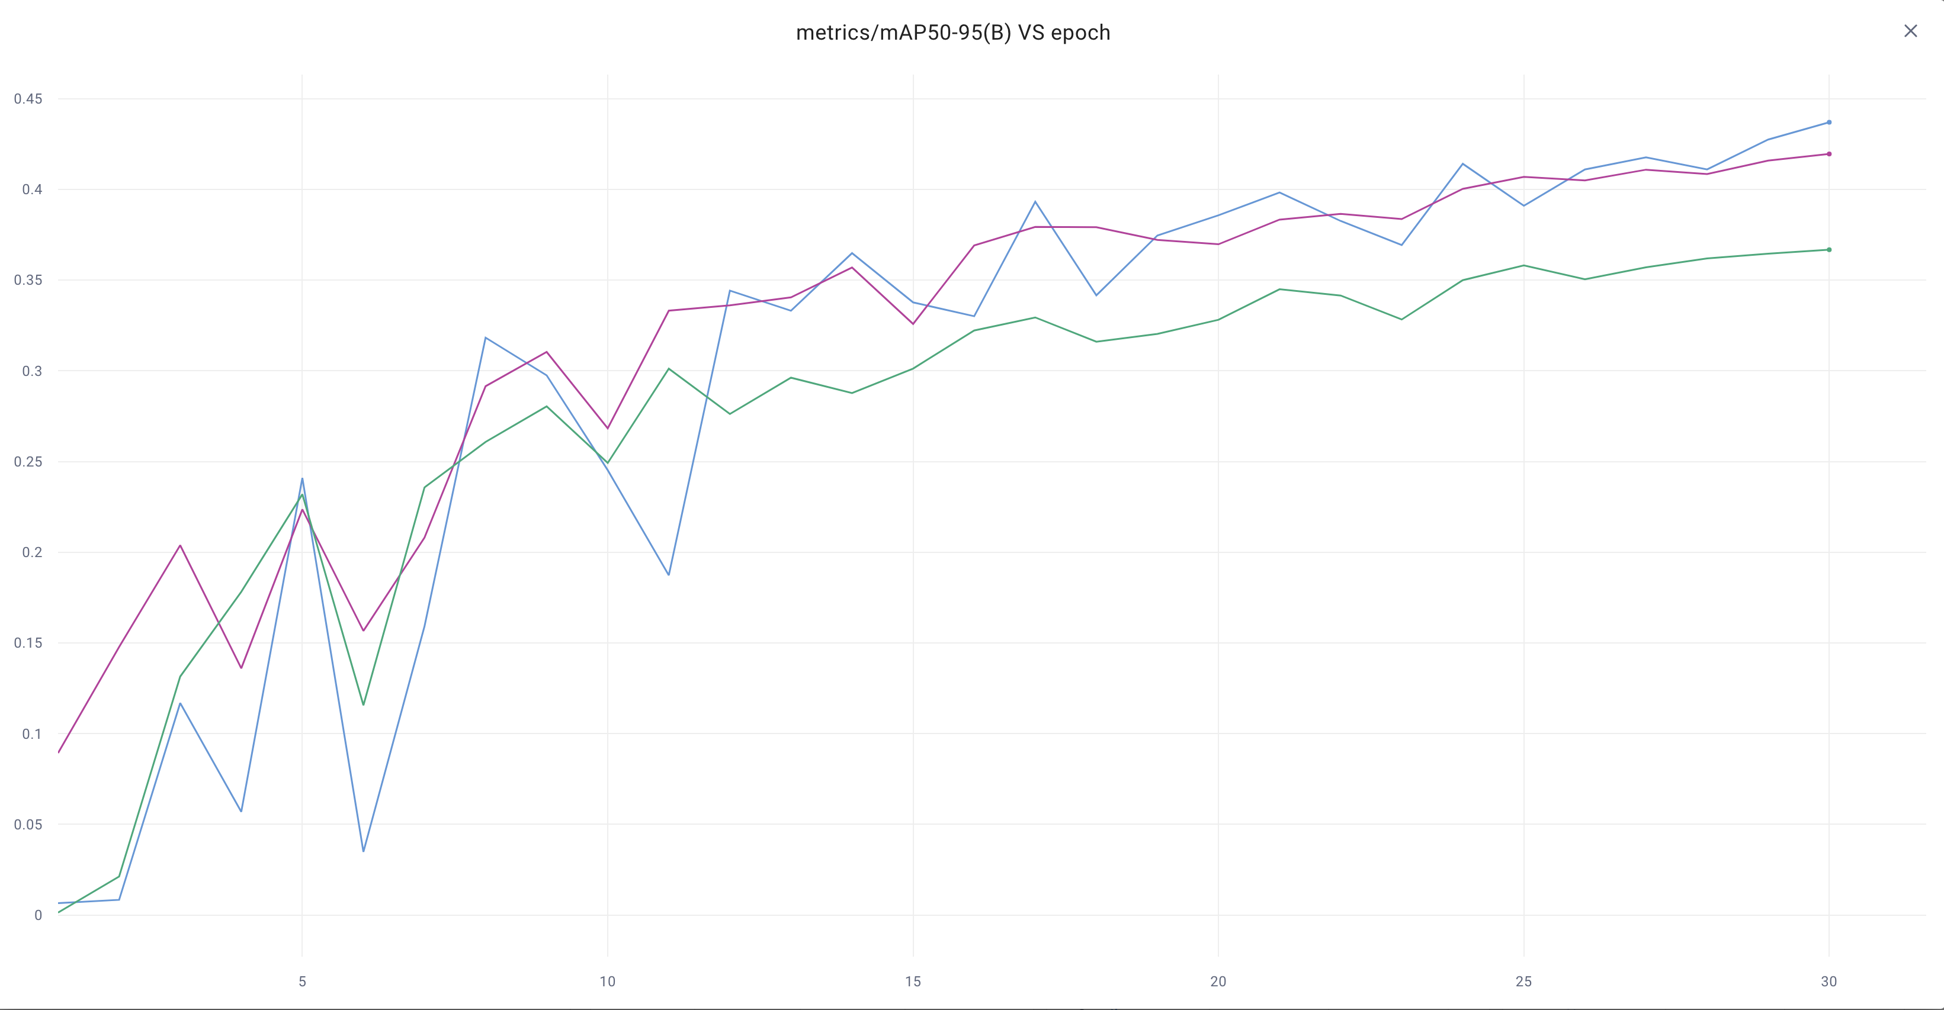

TRAIN VS VAL LOSS GRAPHS:

N:

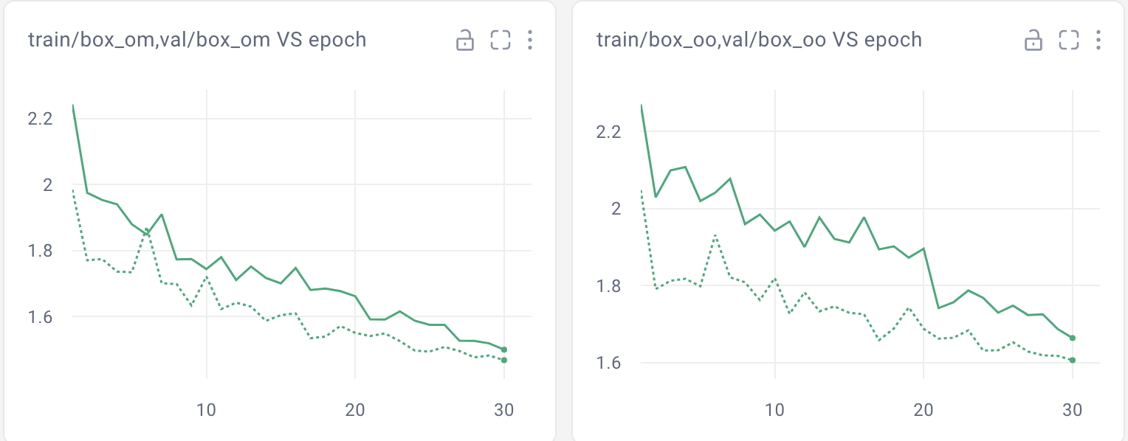

S:

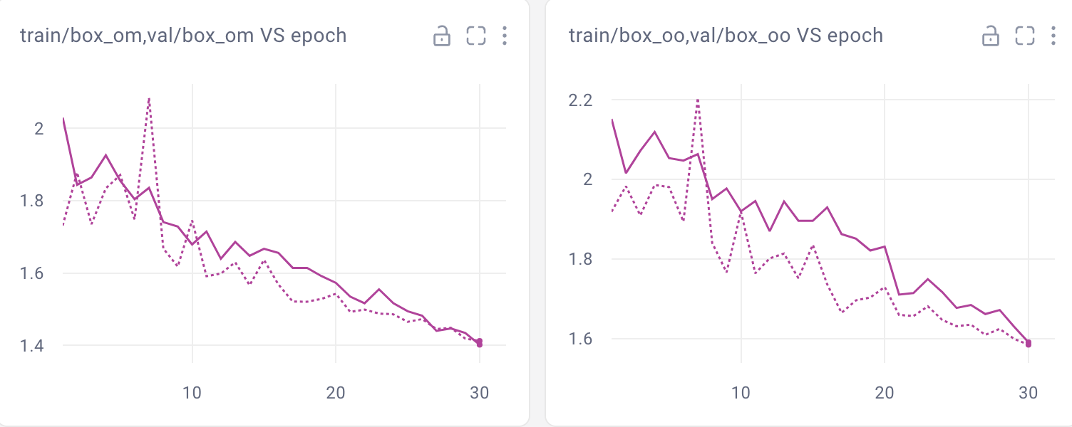

M:

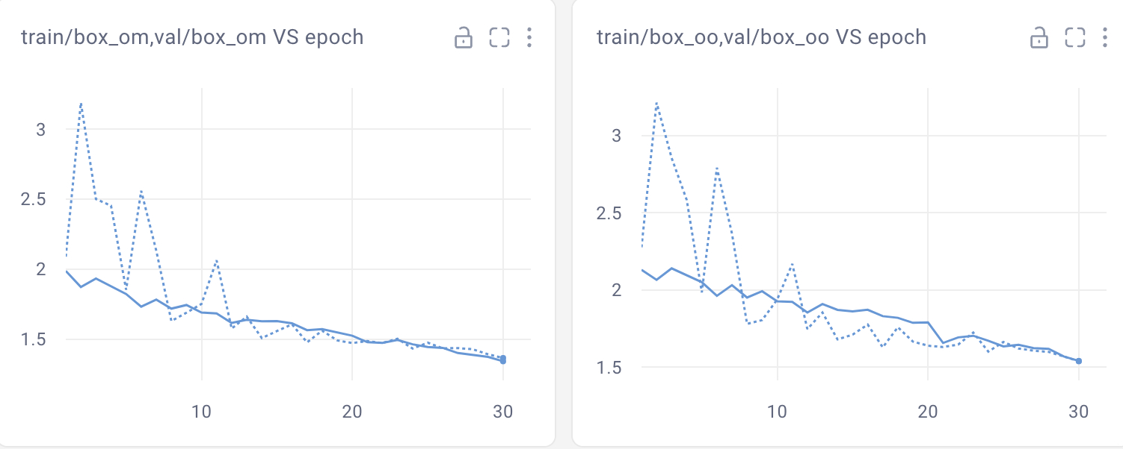

OUTPUTS:

N VS S VS M

N:

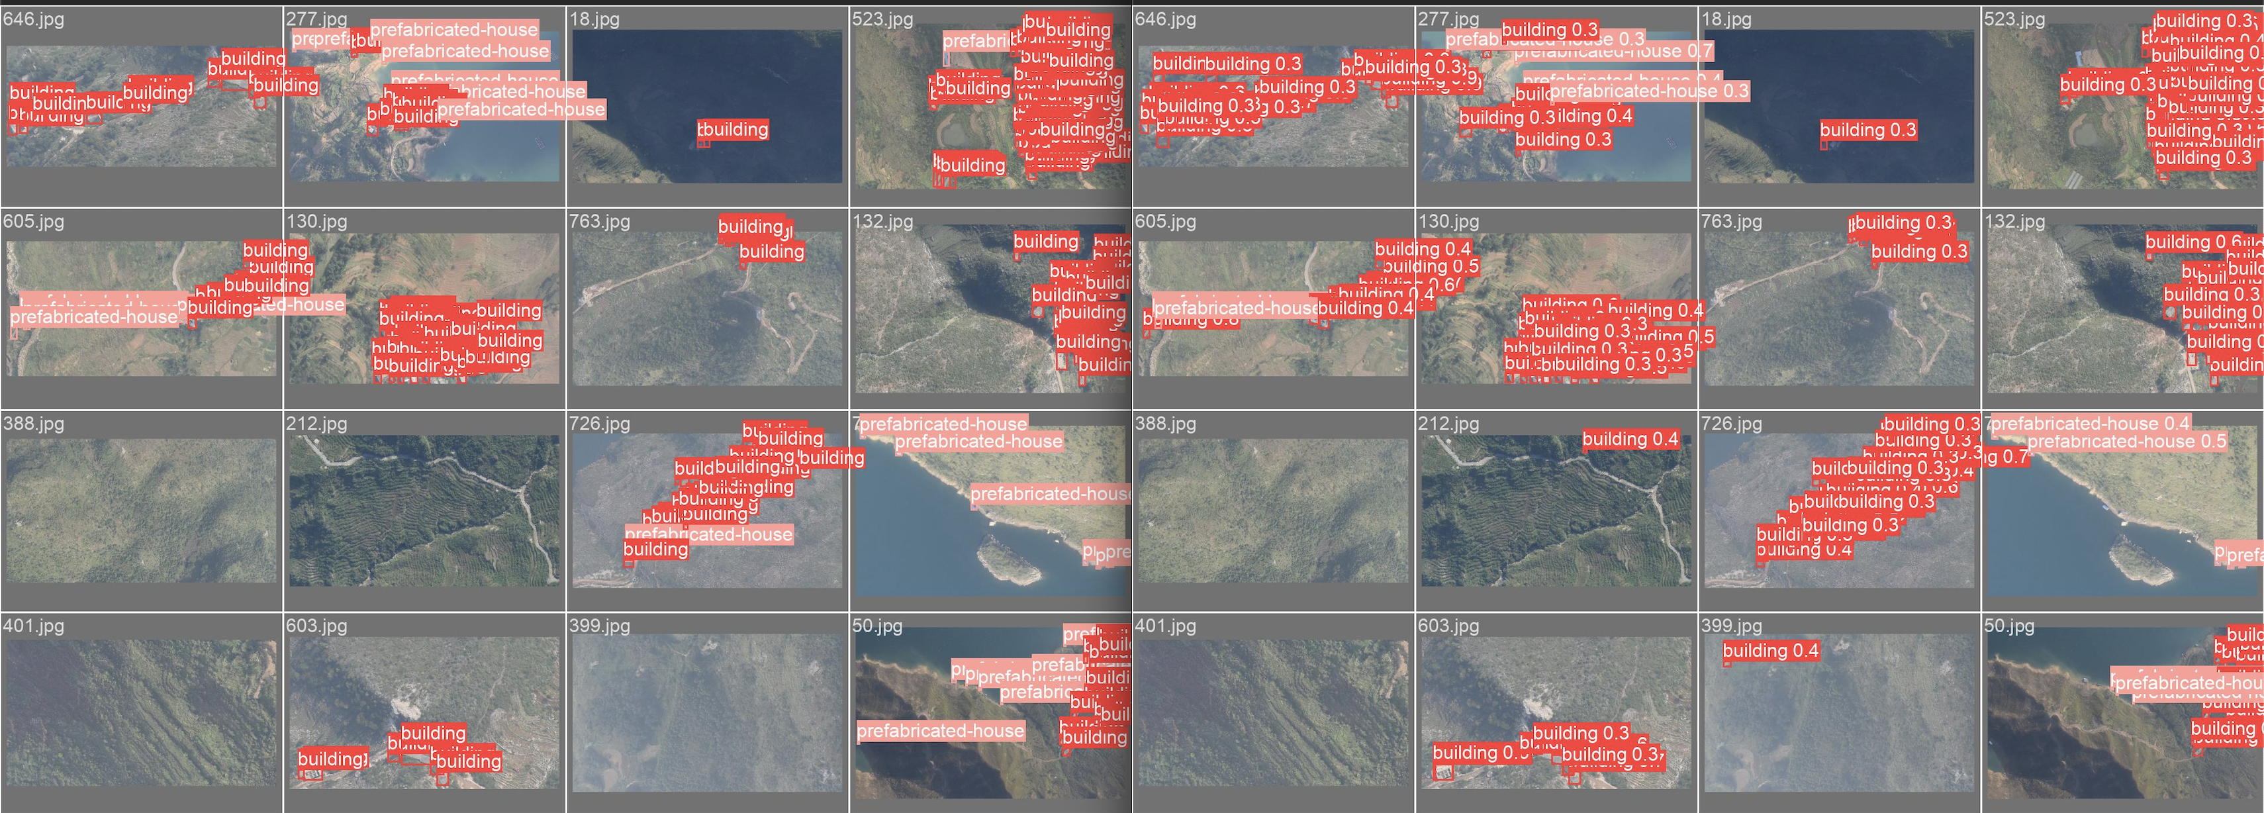

S:

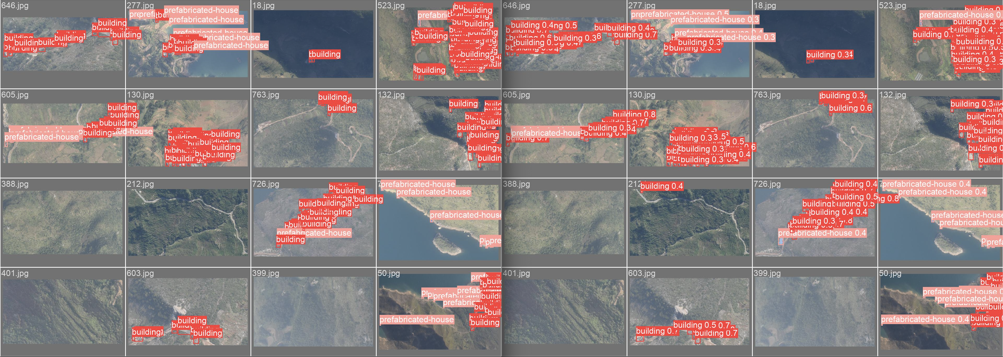

M:

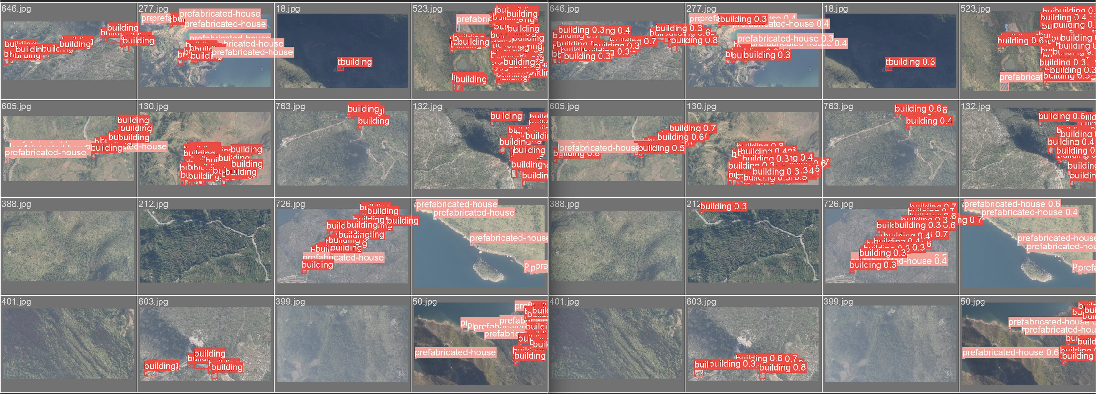

BEST YOLOV8 MODEL VS BEST YOLOV10 MODEL COMPARISON

